**OPEN TO BUY**

**1. GENERAL**

**1.1 Project Description**

1.1.1 Background

1.1.2 Purpose

1.1.3 Assumptions and Constraints

1.1.4 Interfaces to External Systems

**1.2 Points of Contact**

**1.3 Document References**

**2. FUNCTIONAL REQUIREMENTS**

**2.1 Data Requirements**

**2.2 Functional Process Requirements**

**3. OPERATIONAL REQUIREMENTS**

**3.1 Security**

**3.2 Audit Trial**

**3.3 Data Currency**

**3.4 Reliability**

**3.5 Recoverability**

**3.6 System Availability**

**3.7 Fault Tolerance**

**3.8 Performance**

**3.9 Capacity**

**3.10 Data Retention**

**4. REQUIREMENTS TRACE ABILITY MATRIX**

**5. GLOSSARY**

1. **GENERAL** 
   1. **Project Description**

In the fast-paced world of retail, effective decision-making is the key to success. The BMPAS (Retail OTB Analysis System) project is designed to empower retailers with the analytical tools and insights needed to navigate market challenges and make informed decisions, especially for Open-to-Buy (OTB) transactions. Its primary focus is improving decision-making, particularly in Open-to-Buy transactions. Open-to-Buy is the cornerstone of retail operations. It is an important factor in determining the optimal number of items a seller should purchase. Balancing maintaining a complete inventory with avoiding customer dissatisfaction can be a difficult task. OTB plays a key role in this balance, ensuring that retailers meet customer needs while protecting economic flexibility.

* + 1. Background

The BMPAS OTB Module is designed to meet the ever-changing challenges faced by retailers in a dynamic retail environment. All analysis must be based on the information in the database, and all audits must meet the specific conditions specified in the module. For OTB module functionality, the analysis provided by the budget module must be true and all cases must continue to operate within the specified date. This section provides a brief background on the project's inception and its relevance in the retail industry.

* + 1. Purpose

The Buying Options module is a compass that points salespeople in the right direction providing actionable insights into what products to stock, how much to order and when This is done through complex filters and Key Performance Indicators (KPIs)

Customized inventory: The OTB module helps determine the optimal quantity of products to purchase, ensuring that retailers hold enough inventory to meet customer needs and block products the edge of oversales and associated costs.

Comprehensive cash management: This helps vendors maintain a healthy cash position by aligning purchasing decisions with cash flow constraints, thereby reducing the risk of excessive combination of inventory and capital in the decrease

Enhanced decision making: Through data-driven insights and predictions, the module empowers marketers to make informed decisions that increase sales, improve inventory, and drive profitability

* + 1. Assumptions and Constraint

Data Accuracy: The module assumes that data provided for analysis, including historical sales data, inventory, and financial information, are accurate and up-to-date.

Constant demand: It assumes that demand remains constant over the forecast period, resulting in an accurate sales forecast

Market Stability: The module assumes a stable market environment and does not account for extreme external factors that can disrupt the market.

Supply Chain Performance: This assumes that suppliers will consistently adhere to delivery schedules and that there will be no major supply chain disruptions.

Budget Availability: The module assumes that the budget allocated for procurement is available and can be used as planned.

Budget constraints: The module works within the constraints of the allocated budget. Cannot exceed budget limits set by the organization.

Data Limitations: This is constrained by data quality and availability. Inaccurate or incomplete information can affect the accuracy of forecasts and recommendations.

Market fluctuations: Sudden market fluctuations and unexpected disruptions, such as financial crises or natural disasters, are obstacles that the module cannot predict or control.

Vendor dependencies: The module is dependent on supplier performance and cannot reduce the risks associated with supplier-related issues beyond standard procurement criteria.

Resource Limitations: Limitations related to human resources and technical infrastructure may affect the module’s ability to perform real-time analytics or process large amounts of data.

Time constraints: The module works within a specific time frame, and any time delays in data availability or analysis may affect decision-making time

* + 1. Interfaces to External Systems

Inventory Management System:

Purpose: The OTB module should interface with the organization’s inventory management system to obtain actual order levels, inventory, and order status.

Functionality: Can trigger purchase orders, update inventory data and receive stock arrival reports based on OTB recommendations.

Point of Sale (POS) Systems:

Purpose: Integration with the POS system enables the OTB Module to capture sales information, transaction history, and customer purchasing behaviour.

Functionality: Collects real-time sales data for analysis, identifies sales, and forecasts demand based on sales records.

Sales forecasting tools:

Purpose: To increase the accuracy of demand forecasting, the OTB module can interface with external sales forecasting tools or services.

Functionality: Shares historical sales data and market data with the forecasting tool and incorporates generated forecasts into OTB calculations.

Vendors and Vendor Platforms:

Purpose: Interfacing with supplier vendor platforms OTB modules can access supplier lists, pricing, delivery time, and order tracking information.

Functionality: Facilitates the creation of purchase orders, tracks order status, and manages communications with suppliers for timely delivery.

Financial Planning:

Purpose: The module can integrate with an organization’s budget to obtain budget allocations, budget constraints, and cost information.

Efficiency: Ensures purchasing decisions are in accordance with existing budgets, controls expenditures, and generates financial reports.

* 1. **Points of Contact**

Point of Contact for BMAPS

Module Name: OTB

Designation: Project Manager

Contact Person: Sharon Biju

Email: sharonbiju@keyshell.net

Phone: 8129571359

Designation: Project leader

Contact Person: Krishnamohan

Email: krishnamohan@keyshell.net

**1.3 Document References**

**2. FUNCTIONAL REQUIREMENTS**

Our OTB module offers several filters that allow you to narrow down your product selection based on criteria such as category, seasonality, historical sales data, supplier performance, etc. These filters provide you focus on the items most importantly for your business acts as a mirror. Leveraging historical sales data, market trends, and our module gives you actionable insights into the products with the highest potential for profitability.

Make the most of your shelf space and operating cash flow by ensuring that you order the correct quantity of each product. Our OTB module helps you strike a balance between overstocking and understocking, ultimately Maximize your shelf space and operating cash flow by making sure you order the right amount of each product. Our OTB module helps you strike a balance between overstocking and understocking, ultimately

**2.1 Data Requirements**

To create a logical data model with entity relationship diagrams (ERDs), entity definitions and attribute definitions for an OTB (Open to Buy) module is a complex task that often requires collaboration with domain experts and stakeholders work together.

**Entities:**

**Product**

Entity Definition: Represents a product available for purchase.

Attributes:

Item Code

ProductName

Category

Supplier

Cost Price

Retail Price

**Category**

Entity Definition: Represents a product categories

Attributes:

Category

Item Lookup Code

**Supplier**

Entity Definition: Represents suppliers of products.

Attributes:

Supplier

Sub Category Supplier

**Sales Data**

Entity Definition: Stores historical sales data for each product.

Attributes:

Quantity

Net Sales

Item Code

Sold Date

**Inventory**

Entity Definition: Tracks current inventory levels.

Attributes:

Item Code

Quantity

Available Quantity

Item Status

**User**

Entity Definition: Represents system users.

Attributes:

User ID

Username

Password

**Relationships:**

A Product belongs to a Category (Many-to-One).

A Product is supplied by a Supplier (Many-to-One).

Sales Data records are associated with a Product (Many-to-One).

Inventory records are associated with a Product (Many-to-One).

This simplified logic data model provides an overview of the key tasks and their relationships within the OTB module. In a real-world scenario, you can access other services and relationships to capture all data needs including security, compliance, and external data sources Furthermore, the feature definition must include data types, lengths, constraints, and information additional relevant information is included to ensure accuracy and a well-defined data model

**2.2 Functional Process Requirements**

Our OTB module assists customers by using robust business logic to select the optimal product quantity. It takes into account market trends, demand forecasts, and inventory levels, ensuring informed and profitable decisions.

In making data-driven decisions, our OTB module provides accuracy and flexibility. You can set specific requirements such as channels, groups, families, and suppliers, all on defined date ranges. Once your filters are configured, the OTB module will analyse the data and provide you with the specific output you need, ensuring your decisions align with your business objectives.

Purchase Cost = TY Forecast OP STOCK @ Retail Value*(1- First Margin %)

After all the analysis we can see the data ’s in the approved list.

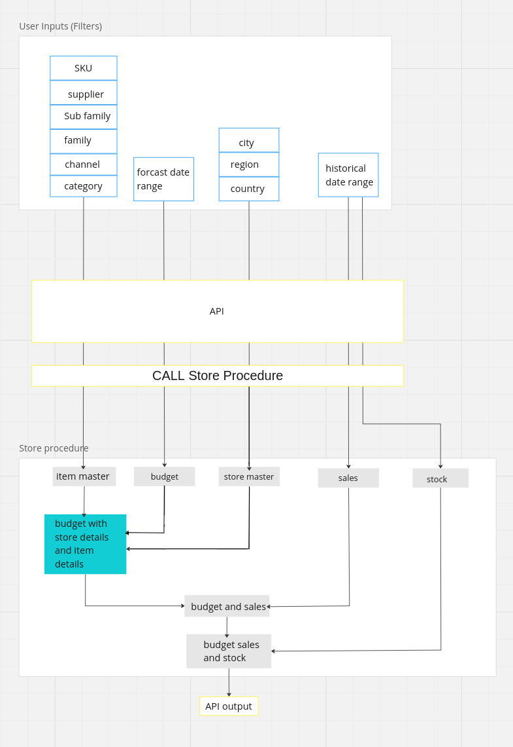

fig.1.0 Work flow of OTB

**3. OPERATIONAL REQUIREMENTS**

In optimizing the Open to Buy (OTB) module, we recognize the critical importance of business requirements that determine its functionality and user satisfaction. Here is a breakdown of these requirements in a business sense:

Performance: It ensures fast response times for tasks like filtering and analysis, supporting concurrent users.

Reliability: The module maintains high availability during business hours and gracefully handles failures.

Scalability: It scales effortlessly with growing data and user demands, handling peak loads.

Compatibility: OTB is compatible with standard browsers and integrates seamlessly with BMAPS retail merchandiser software. These features boost efficiency and user accessibility.

**3.1 Security**

Consequences of security breach:

Delete or corrupt application data:

Consequences: Loss or corruption of critical information can lead to incorrect purchasing decisions, inventory mismanagement, financial losses and negative impacts on business operations

Disclosure of Government Secrets:

Consequences: Unauthorized government secrets can lead to violations of national security, diplomatic data, and legal consequences.

Privileged disclosure of personal information:

Consequences: Unauthorized access to sensitive personal information may result in a breach of privacy, legal liability, and reputational damage

**3.2 Audit Trial**

The audit trail is essential for tracking and monitoring transactions in the OTB (Open to Buy) module to ensure accountability, traceability, and security. Below is a list of activities that should be recorded in the application's audit trail, along with the associated data to be recorded:

User Logins and Logouts:

Data to Record:

User ID or Username

Timestamp of login/logout

IP address or device information

Outcome (successful or failed login attempts)

User Actions:

Data to Record:

User ID or Username

Timestamp of the action

Type of action (e.g., product filtering, data analysis)

Specific action details (e.g., products filtered, parameters used)

Authentication Events:

Data to Record:

User ID or Username

Timestamp of the authentication event

Authentication method used (e.g., username/password, multi-factor authentication)

**3.3 Data Currency**

Data currency is key in any application, especially in a dynamic environment like retail. The OTB (Options to Buy) module requires different types of data, and the currency of that data can vary depending on the specific use case. Here is how to define the data currency required for the data requests in the OTB module:

Product Information: Data currency is needed: Real-time or near-real-time data currencies are needed. Product information must be updated to accurately reflect changes in inventory, pricing, and features.

Historical sales information: Data Currency Requirements: Historical sales data should be updated regularly, preferably daily or in real-time, to provide users with the latest sales information and insights.

Number of reserves: Data Money Requirements: Current inventories must be updated in real time to prevent problems of over-storage or underutilization.

Supplier Performance Data: Data Currency Requirement: Supplier performance data should be updated on an ongoing basis to reflect changes in supplier reliability and quality.

Pricing Data: Data Currency Requirement: Pricing data should be updated in real-time or as soon as price changes are detected to ensure accurate cost calculations.

**3.4 Reliability**

The level of trust required for the OTB (Open to Buy) module is critical to ensure that it supports retail and business operations effectively. The consequences of a system failure can be severe and can include:

Loss of Revenue: The module helps in making purchasing decisions that directly affect revenue. System failures can lead to incorrect purchasing decisions, resulting in financial losses due to overstocking or limited inventory.

Loss of employee productivity: Retailers rely on the OTB module for data-driven insights into purchases. System failures can degrade productivity and reduce employee productivity.

Impact on Customer Experience: When a system failure affects inventory or pricing information, it can result in a negative customer experience due to incorrect availability or pricing

The minimum acceptable reliability of the OTB module must ensure that it operates without significant failure significantly affecting business operations. The following reliability metrics can be used to define the required level of reliability.

The minimum acceptable level of reliability for the OTB module should ensure that it operates without critical failures that significantly impact business operations. The following reliability metrics can be used to define the required level of reliability:

Mean Time Between Failure (MTBF): The OTB module should aim for a high MTBF, indicating a longer average time between system failures. This means the system can operate for an extended period before experiencing a critical failure.

Mean Time to Failure (MTTF): The MTTF should be a high value, indicating that the system is expected to operate for a long time before encountering a failure.

Mean Time to Repair (MTTR): The MTTR should be low, meaning that in the rare event of a system failure, it can be repaired quickly to minimize downtime.

Availability (AVAIL): Availability is the probability that the system is applicable for use at a given time. It takes into account the repair time & the restart time for the system.

OTB modules must be designed and maintained to ensure high levels of reliability, focusing on minimizing system failures and ensuring rapid recovery should any failures occur This level of reliability is essential and to contribute to the efficiency of retail operations activities.

**3.5 Recoverability**

Recoverability is key to system reliability and ensures that an application can quickly resume operations after a failure. For an OTB (Options to Buy) module, the following recoverability requirements should be considered.

Recovery time after system failure:

Recoverability: The application must be able to restore full functionality within a specified period of time after a system failure is detected

Time Limit: Defines the allowable time for processing in the event of a system failure.

Database Corruption Recovery:

Recoverability Requirement: In the event of database corruption, the database must be recoverable to a specified amount, thereby minimizing data loss.

Data Currency Requirement: Specifies the allowable maximum data loss.

This recovery requirement ensures that the OTB module can quickly recover from a system failure, database corruption, or catastrophic event, reducing downtime and data loss Must have specific completion dates its data currencies are aligned with business continuity objectives and are essential for applications in the industry.

**3.6 System Availability**

System Availability The important thing is that the OTB (Open to Buy) module is available to users at the time they need it most. Availability requirements should consider both regular and peak hours. Here is an example of an available policy requirement:

System Hours:

The OTB module must be available to users in the Eastern Standard Time (EST) time zone.

Applications must be received during the following hours:

Monday through Friday, 6:30 a.m. to 5:30 p.m. EST (standard time).

Peak Usage Time: To ensure availability during peak usage, the application must be available for the extended window as follows.

Monday through Friday, 6:30 a.m. to 8:00 p.m. EST.

The specific hours and time zone should be adjusted based on the needs and operating hours of your retail business and its users. These availability requirements help ensure that users have access to the OTB module when they rely on it for critical decision-making during regular and peak times.

**3.7 Fault Tolerance**

**3.8 Performance**

**3.9 Capacity**

**3.10 Data Retention**

**4. REQUIREMENTS TRACE ABILITY MATRIX**

**5. GLOSSARY**